**Portable File Manipulator (pofm)**

Serkan Ekrem Cengiz

Mustafa Salih Oğuz

Sinan Barış Cömert

Ahmet Bahar

**Using this manual:**

1. In order to understand how the program runs.
2. Displaying the interface on your computer.
3. How to use the program through the user guide.

**Contents:**

1. The Main menu.
2. Create a file.
3. Delete a file.
4. Rename a file.
5. Copy a file.
6. Move a file.
7. For text files:
8. Append text to the file.
9. Delete all text in a file.
10. Show the content of the text file.

8. Help Utilities

**1. Main Menu**

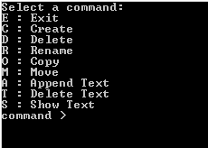If we run the program, command prompt of that system will run and shows the following:

As it can be shown above, the user has to enter a character: E, C, D, R, O, M, A, T or S. The program will close when the user enters "E". We will explain below what happens when the user enters one of the characters except "E".

**1. Create a File**

After entering “C” from the main menu, the user will enter the name of the file user wishes to create as follows: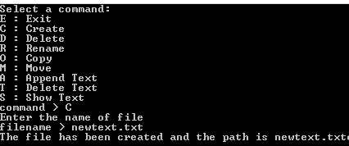

As it can be seen, it shows the output “The file has been created and the path is newtext.txt”.

**3. Delete a File**

After entering “D” from the main menu the user will enter the name of the file user wishes to delete as follows: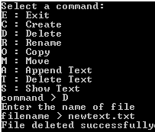

If the file does not exist, it shows output “Error: unable to delete the file”.

As it can be seen above, if the file does exist, the file will be deleted successfully. And shows the output “File deleted successfully”.

**4. Rename a file**

After entering “R” from the main menu the user will enter the name of the file user wishes to rename as follows: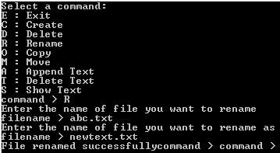

As it can be seen, the program prompts the user the new name for the file. And user has to enter a new name, so shows the output “File renamed successfully”.

In other cases the program will give errors “Error: unable to rename the file”.

**5. Copy a file**

After entering “O” from the main menu the user will enter the name of the file user wishes to copy as follows: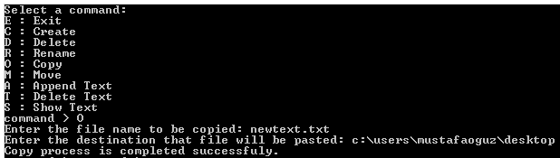

As it can be seen, the program prompts the user enters the destination that file will be pasted, If user enters the new destination, program shows the output “Copy process is completed successfuly”.

But, If the user enters the destination to copy a file, and there is an another file with the same name in that destination, the program gives the user two options :“Destination includes same file named with %s, press 1 to replace, press 2 to cancel copy process:”, and the user enters 1 the program shows the output “Copy process is completed successfuly.”, or the user enters 2 the program shows the output “Copy process is cancelled.”.

In other cases the program will give errors “Source file could not be opened. Copy process is cancelled.”, “Destination could not be accessed. Copy process is cancelled.”, and “Invalid choice. Copy process is cancelled.”.

**6. Move a file**

After entering “M” from the main menu the user will enter the name of the file user wishes to move as follows: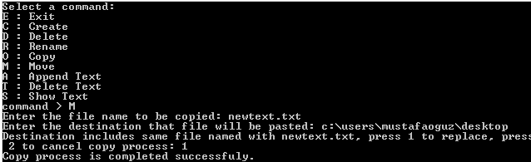

In fact, this function is very similar to the working copying function.

**7. For text files**

1. **Append text to the file:**

After entering “A” from the main menu the user will enter the name of the file user wishes to append text to the file as follows: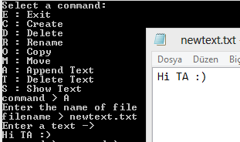

As it can be seen, the program prompts the user to enter a text. And if user enters a random text, so system will append text to the file.

If the file the user enters is existing and there is sufficient memory in the system, so the program will work properly.

If the file does not exist and there is no sufficient memory in the system, so the program gives errors “The file does not exists” and “Disc full or no permission”.

1. **Delete all text in a file:**

After entering “T” from the main menu the user will enter the name of the file user wishes to delete all of the text to the file as follows: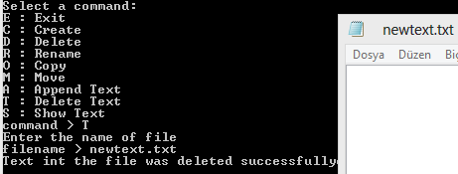

As it can be seen, the program prompts the user enter the name of file. And if the file does exist, the program gives the output “Text int the file was deleted successfully”.

But If the file does not exist, it gives an error “The file does not exists”.

**c. Show the text file:**

The user has to enter “S” for showing the content of a text file. Then, the program prompts user to enter the name of file.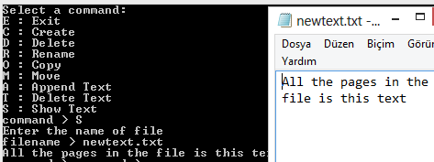

As it can be seen, if the user enters the name of file, the program shows whole text for entered file.

And of course, if the file does not exist, the program will give an error “The file does not exist”.

1. **Help Utilities:**

If user cannot solve how can use the program, help utility can help the users. Help utility includes the explanation for all functions. If the user enters “command /h”, the program gives help according to the command for user to be able to understand and use the command.